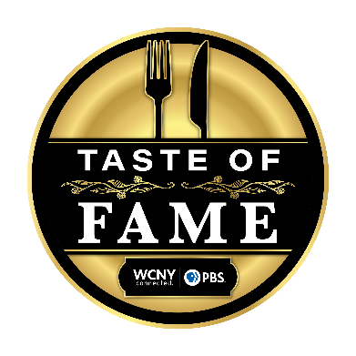

Taste of Fame 2024

VIP Meet & Greet/Cooking Demo Event on Sept. 20:
- Located in the University Room at Drumlins Country Club
  - 800 Nottingham Rd.
Syracuse, NY 13224
- Meet & Greet/Cookbook Signing: 4-5 p.m.
  - Tiffany mingles and takes photos with guests, guests receive signed cookbooks
- Cooking Demonstration: 5-6 p.m.
  - Tiffany prepares her Fried Green Tomatoes in front of a live audience
    - Ingredients and equipment by Drumlins
  - Charlie Miller emcees the cooking demo
  - Headset microphones will be provided for Tiffany and Charlie
  - Handheld microphone will be available for audience questions
  - The cooking demo will not feed the guests, it’s just an in-person cooking demo

Three-Course Dinner (Main Event) on Sept. 20:
- Located in the Grand Ballroom at Drumlins Country Club
  - 800 Nottingham Rd.
Syracuse, NY 13224
- Cocktail Hour: 6-7 p.m.
  - Displayed/Passed Hors d’Oeuvres
  - Signature Cocktail – Peach Koolaid
- Three-Course Dinner: 7-8:45 p.m.
  - Charlie emcees, Tiffany intros each course, visits with guest & sponsor tables
  - Three-Course Menu:
    - Salad Course:
      - Caesar Salad
    - Entrée Choice of:
      - Burnt Sugar Short Ribs
      - Fennel-Roasted Chicken
      - Chargrilled Cabbage
    - Dessert Course:
      - Pistachio Olive Oil Cake
TIMELINE:

FRI., SEPT. 20 (DAY OF EVENT)

- 2-2:30 p.m. – Charlie Miller arrives at Drumlins Country Club
- 2 p.m. – Patti DePaulis (WCNY) drives Tiffany and Naomig to the venue for an event run-through with Charlie (VIP + Dinner), check in with the Chef/kitchen walk through, and pre-signs cookbooks
- 3:15-4 p.m. – Tiffany and Charlie break (snacks/beverages will be provided)
- 4 p.m. - VIP Meet & Greet begins (80 guests)
- 5 p.m. - VIP live cooking demo begins
- 6 p.m. - Cocktail hour begins in the grand ballroom + silent auction
- 6-6:50 p.m. – Tiffany and Charlie break (rest, eat dinner, whatever she would like!)
- 7 p.m. - Three-course dinner begins (260 guests)
- 8:30/8:45 p.m. – Dinner ends

