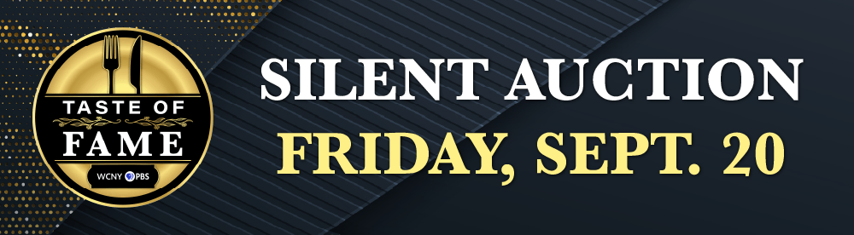

# TASTE OF FAME WITH CHEF TIFFANY DERRY

AT DRUMLINS COUNTRY CLUB, SYRACUSE

WCNY’s Taste of Fame Culinary Experience returns for its 10th year with Celebrity Chef and Restaurateur, Chef Tiffany Derry, most recently recognized as a judge on PBS' "The Great American Recipe," co-host of Food Network's "Worst Cooks in America" and acclaimed chef on "Bobby's Triple Threat," and Bravo's "Top Chef," among other notable achievements!

VIP ticket holders are invited to attend a meet-and-greet/screening event in the University Room at Drumlins Country Club at 4 p.m., prior to the three-course dinner. The VIP event features a meet-and-greet and photo op with Tiffany, hors d'Oeurves and cocktails on the deck, an exclusive screening and Q&A session, and an autographed copy of “The Great American Recipe Cookbook.” Charlie Miller, a local food enthusiast and journalist for syracuse.com, will serve as the

emcee for the VIP event and three-course dinner.

IF INTERESTED IN BEING A PART OF OUR SILENT AUCTION BY DONATING  
AN ITEM(S), GIFT BASKET, OR CERTIFICATE, YOUR COMPANY WOULD   
RECEIVE ONE OF THE FOLLOWING LEVELS IN RETURN FOR YOUR TOTAL   
DONATION DOLLAR VALUE:

**THANK YOU!**

We appreciate your consideration. All donors   
will receive a tax deductible thank you letter at year-end.

To donate or learn more, please contact   
Paul deLaubell at [paul.delaubell@wcny.org](mailto:paul.delaubell@wcny.org)   
or call (315) 385-7405.

**Donation Deadline:**

The deadline to donate is Thursday, Sept. 12. We are happy to receive drop-offs   
or pick up donated items.

**ITEMS $50-$99**

* Logo, link on wcny.org/tasteoffame website
* Included in digital event program
* Company logo included in event signage

**ITEMS $100-$249**

* Above benefits PLUS
* Company logo included in email promotion

**ITEMS $250-$499**

* Above benefits PLUS
* 1 – e-guide ad (email delivered electronically to 30,000 subscribers)
* Thank You recognition in Nov/Dec Connect Magazine

**ITEMS $500+**

* Above benefits PLUS
* Company logo included on wcny.org Taste of Fame web banner
* A blue and white logo

  Description automatically generatedTag on WCNY’s Facebook page (20,000+ followers)