Name ___________________________________________ Date __________________________

Period/Class _________________________________________

Enterprise America Pretest

Directions: Circle the correct letter next to your answer choice or match the letter with the correct item listed.

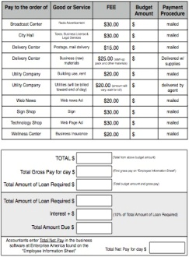1. The form to the right is an example of what?

|  |  |  |
| --- | --- | --- |
|  | A. | Job Application |
|  | B. | Loan Application |
|  | C. | Business Expense Form |

2. GASOLINE is an example of what?

|  |  |  |
| --- | --- | --- |
|  | A. | Capital Resources |
|  | B. | Natural Resources |
|  | C. | Human Resources |

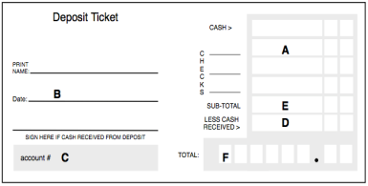3. Match the correct position on the deposit slip with the correct item below.

_____ 1. Account Number

_____ 2. Total Deposit amount

_____ 3. Today’s date is January 24, 2014

_____ 4. Net Deposit amount

_____ 5. $5.00 cash back

_____ 6. $15.00 check

4. A PET is an example of what?

|  |  |  |
| --- | --- | --- |
|  | A. | Want |
|  | B. | Need |
|  | C. | Not Sure |

5. SHELTER is an example of what?

|  |  |  |
| --- | --- | --- |
|  | A. | Want |
|  | B. | Need |
|  | C. | Not Sure |

6. What is a LAW?

|  |  |  |
| --- | --- | --- |
|  | A. | A rule that is agreed to by lawyers and enforced by the police |
|  | B. | A rule that is agreed to by the police and enforced by the community |
|  | C. | A rule that is agreed to by the legislature and enforced by the police |

7. A person who makes goods or performs services is a….

|  |  |  |
| --- | --- | --- |
|  | A. | Producer |
|  | B. | Consumer |
|  | C. | Entrepreneur |

8. A MUSIC CD is an example of what?

|  |  |  |
| --- | --- | --- |
|  | A. | Want |
|  | B. | Need |
|  | C. | Not Sure |

9. A form that people fill out when they want to get a job is a….

|  |  |  |
| --- | --- | --- |
|  | A. | Resume |
|  | B. | Job Application |
|  | C. | References |

10. What is loan interest?

|  |  |  |
| --- | --- | --- |
|  | A. | An amount of money that you do not have to pay back on the loan. |
|  | B. | Money that the bank charges for giving you the loan. |
|  | C. | Money that you have in a savings account to add to the loan. |

11. CLOTHING is an example of what?

|  |  |  |
| --- | --- | --- |
|  | A. | Want |
|  | B. | Need |
|  | C. | Not Sure |

12. GREEN BEANS are an example of what?

|  |  |  |
| --- | --- | --- |
|  | A. | Capital Resources |
|  | B. | Natural Resources |
|  | C. | Human Resources |

13. SAVINGS are an example of what?

|  |  |  |
| --- | --- | --- |
|  | A. | Capital Resources |
|  | B. | Natural Resources |
|  | C. | Human Resources |

14. TV NEWS is an example of what?

|  |  |  |
| --- | --- | --- |
|  | A. | Goods |
|  | B. | Services |
|  | C. | Not Sure |

15. A person who makes signs is a __________.

|  |  |  |
| --- | --- | --- |
|  | A. | Producer |
|  | B. | Consumer |
|  | C. | Not Sure |

16. Taxes paid by citizens help pay for the following jobs and services:

|  |  |  |
| --- | --- | --- |
|  | A. | Veterinarian, dentist, doctor |
|  | B. | Maid, salesmen, chef |
|  | C. | Garbage collectors, mayor, police officers |

17. A BANK LOAN is an example of which of the following?

|  |  |  |
| --- | --- | --- |
|  | A. | Capital Resources |
|  | B. | Natural Resources |
|  | C. | Human Resources |

18. Which of the following is an example of the proper order to make a product or good?

|  |  |  |
| --- | --- | --- |
|  | A. | Make the product, sell to consumers, advertise the product, buy raw materials |
|  | B. | Buy raw materials, make the product, advertise the product, sell to consumers |
|  | C. | Sell to consumers, advertise, buy raw materials, make the product |

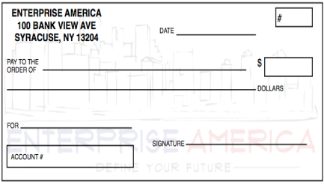19. The form to the right is an example of which of the following?

|  |  |  |
| --- | --- | --- |
|  | A. | Check Register |
|  | B. | Deposit Ticket |
|  | C. | Check |

20. PIZZA is an example of what?

|  |  |  |
| --- | --- | --- |
|  | A. | Goods |
|  | B. | Services |
|  | C. | Not Sure |

21. TEACHING is an example of ….

|  |  |  |
| --- | --- | --- |
|  | A. | Goods |
|  | B. | Services |
|  | C. | Not Sure |

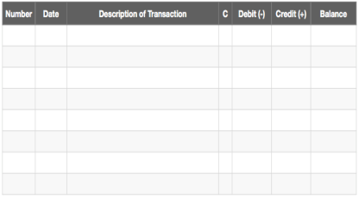22. The form to the right is an example of what?

|  |  |  |
| --- | --- | --- |
|  | A. | Check Register |
|  | B. | Deposit Ticket |
|  | C. | Check |

23. FRENCH FRIES are an example of which of the following?

|  |  |  |
| --- | --- | --- |
|  | A. | Goods |
|  | B. | Services |
|  | C. | Not Sure |

24. FOOD is an example of which of the following?

|  |  |  |
| --- | --- | --- |
|  | A. | Want |
|  | B. | Need |
|  | C. | Not Sure |

25. A GOVERNMENT GRANT is an example of what?

|  |  |  |
| --- | --- | --- |
|  | A. | Capital Resources |
|  | B. | Natural Resources |
|  | C. | Human Resources |

26. A person who pops popcorn is a ___________.

|  |  |  |
| --- | --- | --- |
|  | A. | Producer |
|  | B. | Consumer |
|  | C. | Not Sure |

27. WATER is which of the following?

|  |  |  |
| --- | --- | --- |
|  | A. | Want |
|  | B. | Need |
|  | C. | Not Sure |

28. A person who writes a newspaper article is a _____________.

|  |  |  |
| --- | --- | --- |
|  | A. | Producer |
|  | B. | Consumer |
|  | C. | Not Sure |

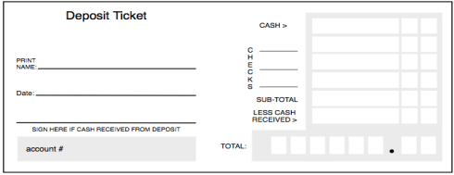29. The form to the right is an example of what?

|  |  |  |
| --- | --- | --- |
|  | A. | Check Register |
|  | B. | Deposit Ticket |
|  | C. | Check |

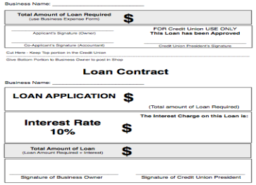30. The form to the right is an example of what?

|  |  |  |
| --- | --- | --- |
|  | A. | Job Application |
|  | B. | Loan Application |
|  | C. | Business Expense Form |

31. A person who buys goods and services is a….

|  |  |  |
| --- | --- | --- |
|  | A. | Producer |
|  | B. | Consumer |
|  | C. | Entrepreneur |

32. A person, who starts, manages and assumes the risks of his or her own business, is a….

|  |  |  |
| --- | --- | --- |
|  | A. | Producer |
|  | B. | Consumer |
|  | C. | Entrepreneur |

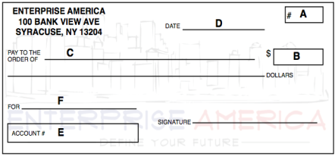33. Using the following information, match the letter on the check with the correct information listed below.

Complete check number 26 for $11.50 to the Smith Brother’s Sports Shop to pay for a basketball. Your account number is 45 and the date is October 10, 2013.

|  |  |  |
| --- | --- | --- |
| ___ 1. 10/21/13  ___ 2. 26  ___ 3. 45  ___ 4. $11.50  ___ 5. Smith Brother’s Sports Shop  ___ 6. Basketball |  |  |

34. If there is a small demand for ice cream and a big supply of ice cream, how would this affect the price?

A. The price of ice cream should be high

B. The price of ice cream should be low

C. Not Sure

35. BOOKS are example of which of the following?

|  |  |  |
| --- | --- | --- |
|  | A. | Goods |
|  | B. | Services |
|  | C. | Not Sure |

36. You have enough money to buy a music CD, a movie ticket or a pet fish. You buy the music CD. What are your opportunity costs?

|  |  |  |
| --- | --- | --- |
|  | A. | Pet fish and movie ticket |
|  | B. | Music cd and pet fish |
|  | C. | Movie and music cd |

37. A BOOK KEEPER is an example of which of the following?

|  |  |  |
| --- | --- | --- |
|  | A. | Capital Resources |
|  | B. | Natural Resources |
|  | C. | Human Resources |

38. CAR REPAIRS are an example of which of the following?

|  |  |  |
| --- | --- | --- |
|  | A. | Goods |
|  | B. | Services |
|  | C. | Not Sure |

39. WATER is an example of which of the following?

|  |  |  |
| --- | --- | --- |
|  | A. | Capital Resources |
|  | B. | Natural Resources |
|  | C. | Human Resources |

40. You are told you need to endorse your check, what does this mean?

|  |  |  |
| --- | --- | --- |
|  | A. | Sign the back of the check |
|  | B. | Put the date on the check |
|  | C. | Enter the check in your register |

41. Match this definition with the correct term:

The list of people an employer contacts to learn about someone applying for a job is called what?

|  |  |  |
| --- | --- | --- |
|  | A. | Resume |
|  | B. | Entrepreneur |
|  | C. | References |

42. A summary of a person's work experience, skills, talents, interests and awards on one document, is an example of what?

|  |  |  |
| --- | --- | --- |
|  | A. | Job Application |
|  | B. | Resume |
|  | C. | References |

43. A person who uses electricity is a ___________.

|  |  |  |
| --- | --- | --- |
|  | A. | Producer |
|  | B. | Consumer |
|  | C. | Not Sure |

44. If you have an **abundance** of aproduct, how much would it cost compared to a **scarce** product?

|  |  |  |
| --- | --- | --- |
|  | A. | More |
|  | B. | Less |
|  | C. | Same As |
|  |  |  |

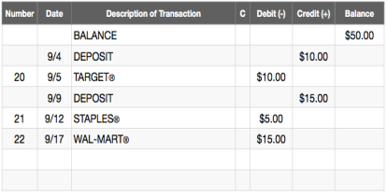45. Using the Check Register pictured to the right and the information below to determine the ending balance.

Your opening balance is $50.00. On September 4, you deposited $10.00 from a babysitting job from Mrs. Smith. You wrote out check #20 for $10.00 to Target® for a new backpack. On September 9, you deposited $15.00 from your Uncle Joe for a birthday present. Check #21 went towards notebooks from Staples for $5.00 on September 12. You paid Wal-Mart, $15.00 for a video game on September 17. This was check #22.

What is your ending balance?

|  |  |  |
| --- | --- | --- |
|  | A. | $45.00 |
|  | B. | $100.00 |
|  | C. | $5.00 |
|  | D. | $70.00 |

46. What does profit mean?

|  |  |  |
| --- | --- | --- |
|  | A. | The money a business is paid for selling its goods and services |
|  | B. | The money a business has left over after subtracting production costs |
|  | C. | Not sure |

47. BABYSITTING is an example of which of the following?

|  |  |  |
| --- | --- | --- |
|  | A. | Goods |
|  | B. | Services |
|  | C. | Not Sure |

48. A BANK TELLER is an example of what?

|  |  |  |
| --- | --- | --- |
|  | A. | Capital Resources |
|  | B. | Natural Resources |
|  | C. | Human Resources |

49. A person who buys flowers is a ____________.

|  |  |  |
| --- | --- | --- |
|  | A. | Producer |
|  | B. | Consumer |
|  | C. | Not Sure |

50. The form below is an example of what?

|  |  |  |
| --- | --- | --- |
|  | A. | Job Application |
|  | B. | Loan Application |
|  | C. | Business Expense Form |
|  |  |  |

Enterprise America Pre-Test : Answer Key

|  |  |
| --- | --- |
| **1.** | **C** |
| **2.** | **B** |
| **3.** | **C: F: B: E: D: A** |
| **4.** | **A** |
| **5.** | **B** |
| **6.** | **C** |
| **7.** | **A** |
| **8.** | **A** |
| **9.** | **B** |
| **10.** | **B** |
| **11.** | **B** |
| **12.** | **C** |
| **13.** | **A** |
| **14.** | **B** |
| **15.** | **A** |
| **16.** | **C** |
| **17.** | **A** |
| **18.** | **B** |
| **19.** | **C** |
| **20.** | **A** |
| **21.** | **B** |
| **22.** | **A** |
| **23.** | **A** |
| **24.** | **B** |
| **25.** | **A** |
| **26.** | **A** |
| **27.** | **B** |
| **28.** | **A** |
| **29.** | **B** |
| **30.** | **B** |
| **31.** | **B** |
| **32.** | **C** |
| **33.** | **D: A: E: B: C: F** |
| **34.** | **B** |
| **35.** | **A** |
| **36.** | **A** |
| **37.** | **C** |
| **38.** | **B** |
| **39.** | **B** |
| **40.** | **A** |
| **41.** | **C** |
| **42.** | **B** |
| **43.** | **B** |
| **44.** | **B** |
| **45.** | **A** |
| **46.** | **B** |
| **47.** | **B** |
| **48.** | **C** |
| **49.** | **B** |
| **50.** | **A** |