Name _____________________________________________________ Date _______________________________

Period/Class ____________________________________

Enterprise America Post Test

Directions: Circle the correct letter next to your answer choice or match the letter with the correct item listed.

1. A VIDEO GAME is an example of what?

|  |  |  |
| --- | --- | --- |
|  | A. | Wants |
|  | B. | Needs |
|  | C. | Not Sure |

2. SHOES are an example of what?

|  |  |  |
| --- | --- | --- |
|  | A. | Wants |
|  | B. | Needs |
|  | C. | Not Sure |

3. VEGETABLES are an example of what?

|  |  |  |
| --- | --- | --- |
|  | A. | Wants |
|  | B. | Needs |
|  | C. | Not Sure |

4. SHELTER is an example of what?

|  |  |  |
| --- | --- | --- |
|  | A. | Wants |
|  | B. | Needs |
|  | C. | Not Sure |

5. HEAT is an example of what?

|  |  |  |
| --- | --- | --- |
|  | A. | Wants |
|  | B. | Need |
|  | C. | Not Sure |

6. A SKATEBOARD is an example of what?

|  |  |  |
| --- | --- | --- |
|  | A. | Wants |
|  | B. | Needs |
|  | C. | Not Sure |

7. You have enough money to buy shoes, gloves or a skateboard. You buy the skateboard. What are your opportunity costs?

|  |  |  |
| --- | --- | --- |
|  | A. | Shoes and gloves |
|  | B. | Gloves and skateboard |
|  | C. | Skateboard and shoes |

8. If there is a big demand for popcorn and a small supply of popcorn, how will this affect the price?

|  |  |  |
| --- | --- | --- |
|  | A. | The price of popcorn should be low |
|  | B. | The price of popcorn should be high |
|  | C. | The price of popcorn will not change. |

9. The definition of profit is _________.

|  |  |  |
| --- | --- | --- |
|  | A. | The money a company makes in sales minus production costs. |
|  | B. | The money a company makes in sales of its good and services. |
|  | C. | The money a company makes and donates to a non-profit organization. |

10. The person who makes a video game is called a ____________.

|  |  |  |
| --- | --- | --- |
|  | A. | Producer |
|  | B. | Consumer |
|  | C. | Entrepreneur |

11. The person who pops popcorn is called a____________.

|  |  |  |
| --- | --- | --- |
|  | A. | Producer |
|  | B. | Consumer |
|  | C. | Entrepreneur |

12. The person who buys a newspaper is called a ___________

|  |  |  |
| --- | --- | --- |
|  | A. | Consumer |
|  | B. | Producer |
|  | C. | Entrepreneur |

13. The person who goes to a movie is called a _____________

|  |  |  |
| --- | --- | --- |
|  | A. | Producer |
|  | B. | Consumer |
|  | C. | Entrepreneur |

14. The person who eats at a restaurant is called a __________.

|  |  |  |
| --- | --- | --- |
|  | A. | Producer |
|  | B. | Consumer |
|  | C. | Business owner |

15. Usually if a product becomes ***scarce***, what happens to the price?

|  |  |  |
| --- | --- | --- |
|  | A. | Goes up |
|  | B. | Stays the same |
|  | C. | Goes down |
|  |  |  |

16. OIL is an example of what?

|  |  |  |
| --- | --- | --- |
|  | A. | Capital Resource |
|  | B. | Natural Resource |
|  | C. | Human Resource |

17. An AIRPLANE PILOT is an example of what?

|  |  |  |
| --- | --- | --- |
|  | A. | Capital Resource |
|  | B. | Natural Resource |
|  | C. | Human Resource |

18. A DISC JOCKEY is an example of what?

|  |  |  |
| --- | --- | --- |
|  | A. | Capital Resource |
|  | B. | Natural Resource |
|  | C. | Human Resource |

19. A CHECKING ACCOUNT is an example of what?

|  |  |  |
| --- | --- | --- |
|  | A. | Capital Resources |
|  | B. | Natural Resources |
|  | C. | Human Resources |

20. APPLES are an example of what?

|  |  |  |
| --- | --- | --- |
|  | A. | Capital Resources |
|  | B. | Natural Resources |
|  | C. | Human Resources |

21. A BUSINESS LOAN is an example of what?

|  |  |  |
| --- | --- | --- |
|  | A. | Capital Resources |
|  | B. | Natural Resources |
|  | C. | Human Resources |

22. An ACCOUNTANT is an example of what?

|  |  |  |
| --- | --- | --- |
|  | A. | Capital Resources |
|  | B. | Natural Resources |
|  | C. | Human Resources |

23. WATER is an example of what?

|  |  |  |
| --- | --- | --- |
|  | A. | Capital Resources |
|  | B. | Natural Resources |
|  | C. | Human Resources |
|  |  |  |

24. HAMBURGERS are an example of what?

|  |  |  |
| --- | --- | --- |
|  | A. | Goods |
|  | B. | Services |
|  | C. | Natural Resources |

25. HAIRCUTS are an example of what?

|  |  |  |
| --- | --- | --- |
|  | A. | Goods |
|  | B. | Services |
|  | C. | Entrepreneurship |

26. HOUSE PAINTING is an example what?

|  |  |  |
| --- | --- | --- |
|  | A. | Goods |
|  | B. | Services |
|  | C. | Not Sure |

27. MEDICAL INSURANCE is an example of what?

|  |  |  |
| --- | --- | --- |
|  | A. | Goods |
|  | B. | Services |
|  | C. | Not Sure |

28. A music CD is an example of what?

|  |  |  |
| --- | --- | --- |
|  | A. | Goods |
|  | B. | Services |
|  | C. | Not Sure |

29. PENCILS are an example of what?

|  |  |  |
| --- | --- | --- |
|  | A. | Goods |
|  | B. | Services |
|  | C. | Not Sure |

30. CARS are an example of what?

|  |  |  |
| --- | --- | --- |
|  | A. | Goods |
|  | B. | Services |
|  | C. | Not Sure |

31. In the United States, a law is a rule that is made by a ___________ and enforced by the police.

|  |  |  |
| --- | --- | --- |
|  | A. | Legislature |
|  | B. | Business group |
|  | C. | Committee of lawyers |

32. What is loan interest?

|  |  |  |
| --- | --- | --- |
|  | A. | Money that is not paid back on a loan |
|  | B. | Money that the bank charges for a loan |
|  | C. | Money that the bank is interested in giving a business |

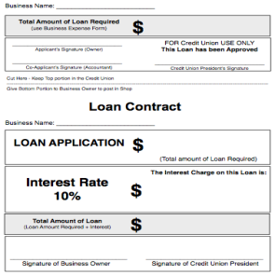33. This form is an example of what?

|  |  |  |
| --- | --- | --- |
|  | A. | Loan Application |
|  | B. | Business Expense Form |
|  | C. | Job Application |

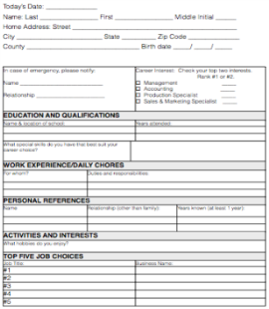34. This form is an example of what?

|  |  |  |
| --- | --- | --- |
|  | A. | Loan Application |
|  | B. | Business Expense Form |
|  | C. | Job Application |

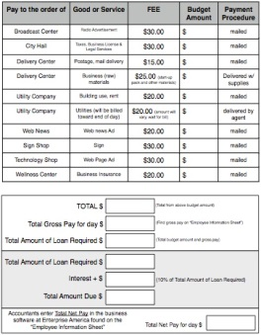35. This form is an example of what?

|  |  |  |
| --- | --- | --- |
|  | A. | Loan Application |
|  | B. | Business Expense Form |
|  | C. | Job Application |
|  |  |  |

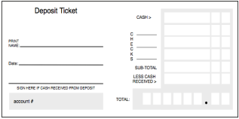36. This form is an example of what?

|  |  |  |
| --- | --- | --- |
|  | A. | Check Register |
|  | B. | Check |
|  | C. | Deposit Ticket |

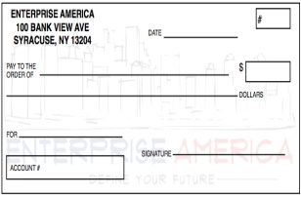37. This form is an example of what?

|  |  |  |
| --- | --- | --- |
|  | A. | Check Register |
|  | B. | Check |
|  | C. | Deposit Ticket |

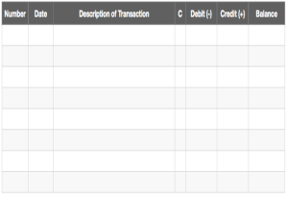38. This form is an example of what?

|  |  |  |
| --- | --- | --- |
|  | A. | Check Register |
|  | B. | Check |
|  | C. | Deposit Ticket |

39. How do you endorse a check?

|  |  |  |
| --- | --- | --- |
|  | A. | Sign your name on the front |
|  | B. | Sign your name on the back |
|  | C. | Fill out the date and amount |

40. A summary of a person's work experience, skills, talents, interests and awards is a description of what type of document?

|  |  |  |
| --- | --- | --- |
|  | A. | Job Application |
|  | B. | References |
|  | C. | Resume |

41. The list of people an employer contacts to learn about someone who is applying for a job, is a description of what document?

|  |  |  |
| --- | --- | --- |
|  | A. | Job Application |
|  | B. | References |
|  | C. | Resume |

42. A person who starts, manages and assumes the risks of his or her own business is called what?

|  |  |  |
| --- | --- | --- |
|  | A. | Producer |
|  | B. | Entrepreneur |
|  | C. | Consumer |

43. A person who buys goods and services is called what?

|  |  |  |
| --- | --- | --- |
|  | A. | Consumer |
|  | B. | Entrepreneur |
|  | C. | Producer |

44. A form that people fill out when they want to get a job is called what?

|  |  |  |
| --- | --- | --- |
|  | A. | Job Application |
|  | B. | Resume |
|  | C. | References |

45. A person who makes goods or performs services is called what?

|  |  |  |
| --- | --- | --- |
|  | A. | Entrepreneur |
|  | B. | Producer |
|  | C. | Consumer |

46. Match the correct position of the deposit slip with the correct information for that blank.

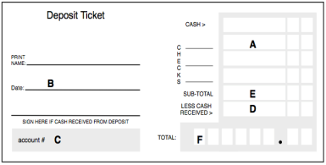

|  |  |  |
| --- | --- | --- |
| ______ 1. A check for $15.00  ______ 2. Net Deposit  ______ 3.Total Deposit  ______ 4. Account number  ______ 5. Date  ______ 6. $10.00 cash back |  |  |

47. Use the following information to match the letter with what is needed to complete the check.

The check number is 21. The items cost $17.30. Sound Works® is who you are paying for the 2 CD's you want. The account number is 86. The items were purchased on 10/25/13

|  |  |  |
| --- | --- | --- |
| ______ 1. 10/25/13  ______ 2. 2 CD’s  ______ 3. Check # 21  ______ 4. Sound Works  ______ 5. $17.30  ______ 6. Account # 86 |  | http://topaz.quiz-maker.net/uploads/13208.png |

48. Which of the following lists shows the most likely production pattern order?

|  |  |  |
| --- | --- | --- |
|  | A. | advertise the product, make the product, buy raw materials, sell to consumers |
|  | B. | sell to consumers, advertise, buy raw materials, make the product |
|  | C. | buy raw materials, make the product, advertise the product, sell to consumers |
|  |  |  |

Use the information in the paragraph below to fill out the check register and find your ending balance.

49. Your opening balance is $65.00. On April 3rd you deposit $10.00 from a painting job for Mr. Stewart. You entered check number 50 and wrote Walmart for the new book bag you bought for $10.00 on April 10th. You also, enter Check number 51 for the 15.00 pizza you bought from Pizza Hut on April 12th. On April 16th you deposit $20.00 from your Uncle Larry for a birthday present. Last entry is check number 52, you wrote this to Radio Shack for a $20.00 video game on April 30th.

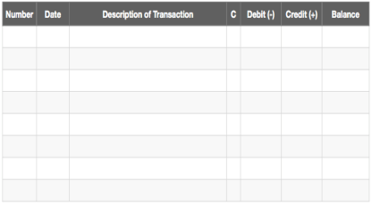

What is your ending balance?

|  |  |  |
| --- | --- | --- |
|  | A. | $60.00 |
|  | B. | $125.00 |
|  | C. | $50.00 |
|  |  |  |

50. Taxes paid by citizens help pay for the following jobs and services:

|  |  |  |
| --- | --- | --- |
|  | A. | Police officer, mayor, garbage collector |
|  | B. | Chef, salesmen, maid |
|  | C. | Lawyer, security guard, builder |

Enterprise America Post Test : Answer Key

|  |  |
| --- | --- |
| 1. | A |
| 2. | A |
| 3. | B |
| 4. | B |
| 5. | B |
| 6. | A |
| 7. | A |
| 8. | B |
| 9. | A |
| 10. | A |
| 11. | A |
| 12. | A |
| 13. | B |
| 14. | B |
| 15. | A |
| 16. | B |
| 17. | C |
| 18. | C |
| 19. | A |
| 20. | B |
| 21. | A |
| 22. | C |
| 23. | B |
| 24. | A |
| 25. | B |
| 26. | B |
| 27. | B |
| 28. | A |
| 29. | A |
| 30. | A |
| 31. | A |
| 32. | B |
| 33. | A |
| 34. | C |
| 35. | B |
| 36. | C |
| 37. | B |
| 38. | A |
| 39. | B |
| 40. | C |
| 41. | B |
| 42. | B |
| 43. | A |
| 44. | A |
| 45. | B |
| 46. | A: E: F: C: B: D |
| 47. | D: F: A: C: B: E |
| 48. | C |
| 49. | C |
| 50. | A |