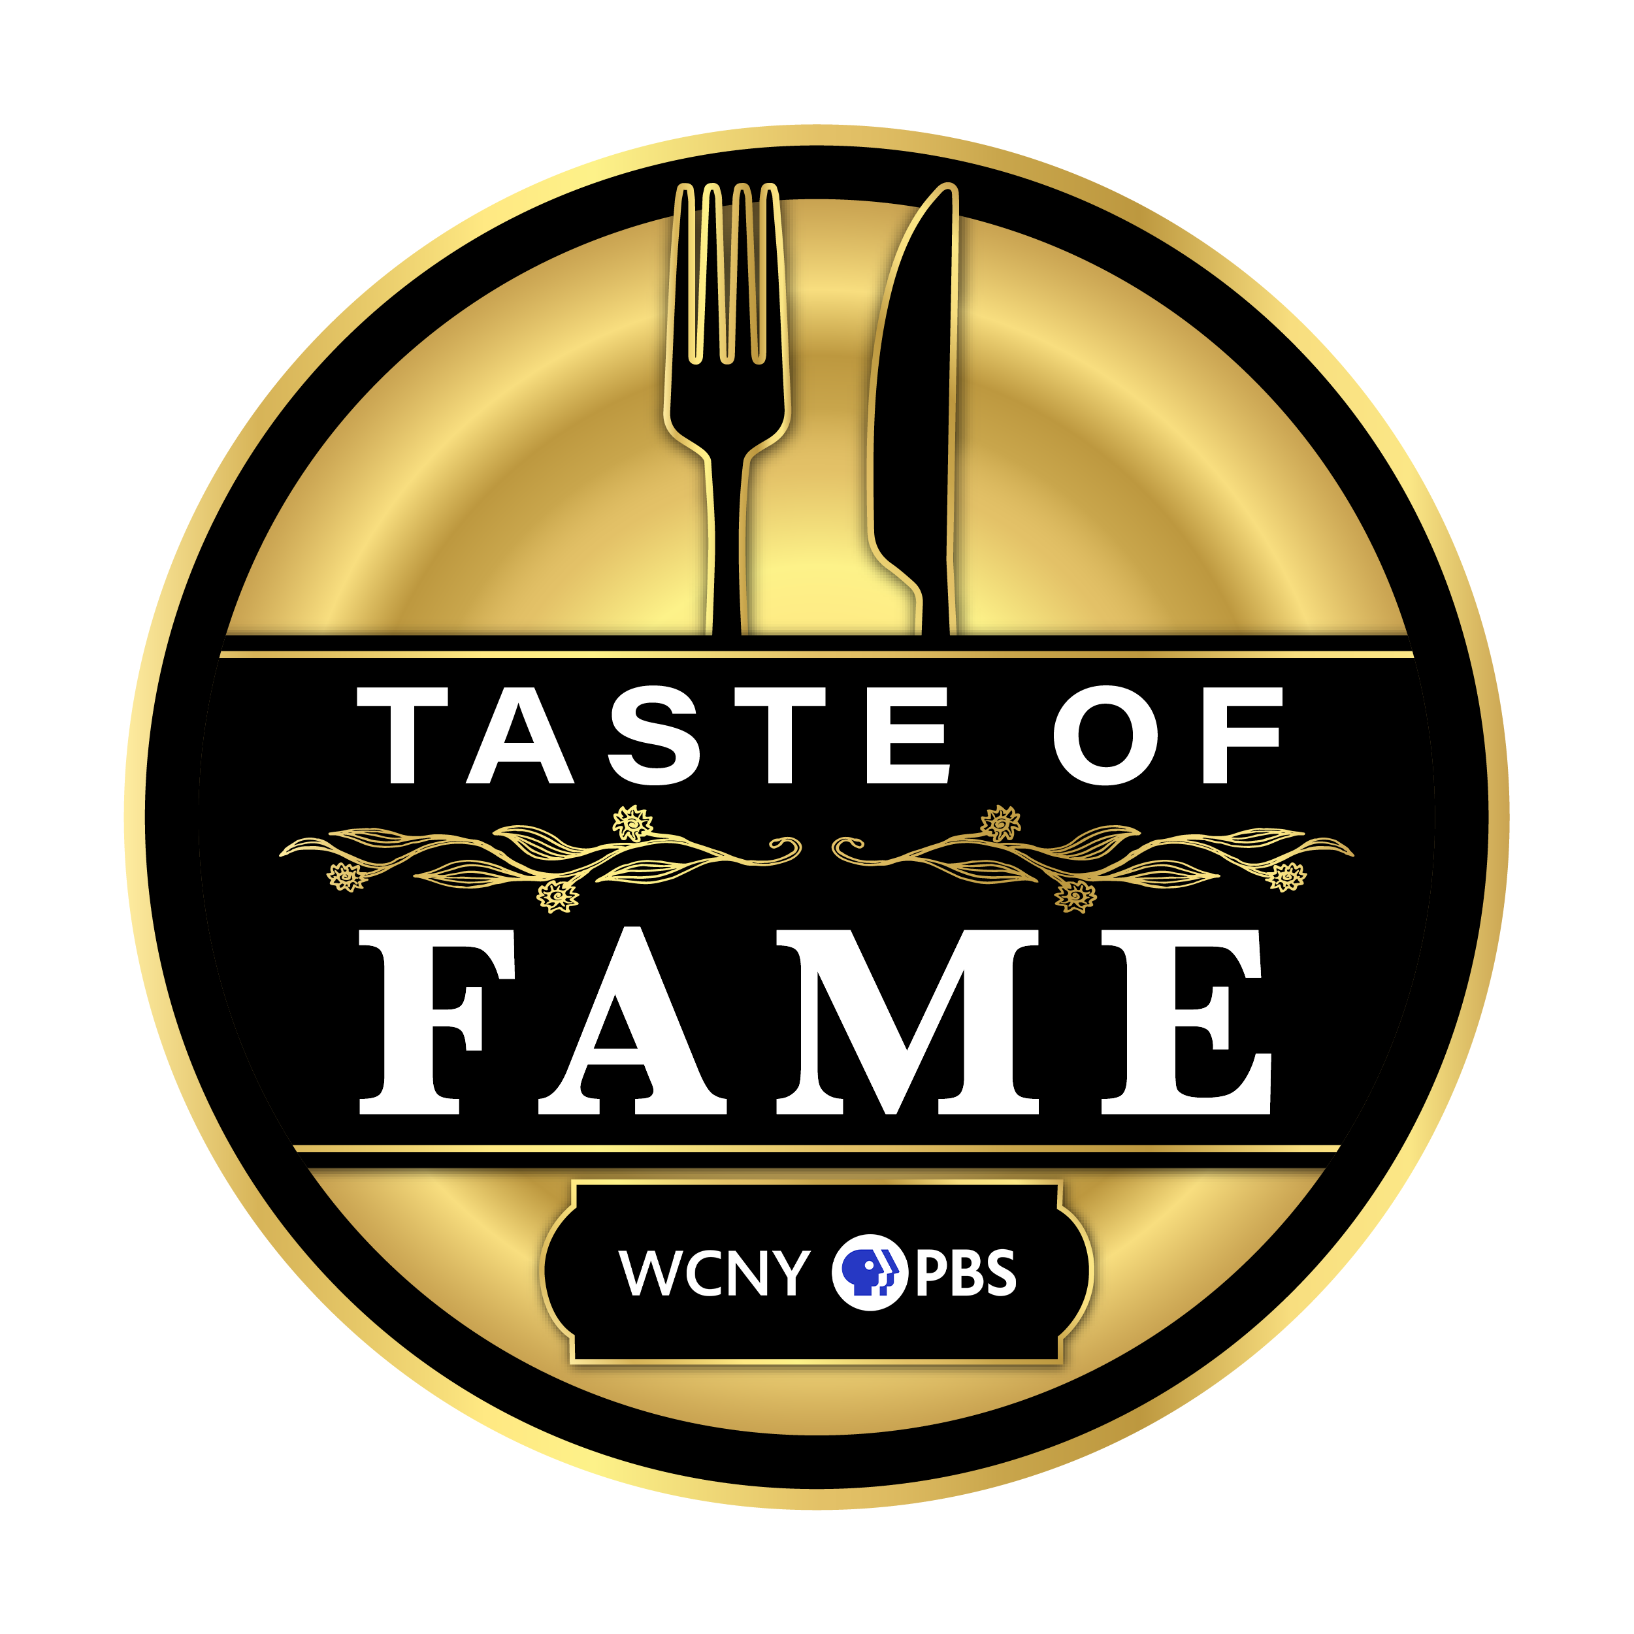

Taste of Fame FAQ
September 20

General

Q: Who will be hosting this year's Taste of Fame?
A: Chef Tiffany Derry of PBS’ “The Great American Recipe” will be hosting our 10th annual Taste of Fame culinary experience!

Q: What time does the Taste of Fame event begin?
A: The event begins at 6 p.m. with cocktail hour and a silent auction, and the three-course dinner experience begins at 7 p.m.

Q: When and where will Taste of Fame take place?
A: This year's event will take place on Friday, Sept. 20 at Drumlins Country Club.

Q: Where is Drumlins Country Club located?
A: 800 Nottingham Road Syracuse, NY 13224.

Q: How can I share photos from the event?
A: Use #Tasteoffame24 to share your photos with Taste of Fame!

Tickets

Q: When do ticket sales close?
A: Ticket sales close Sept. 9 at midnight.

Q: Where do I go to purchase tickets?
A: Please visit our page on OneCause to purchase tickets to Taste of Fame.

Q: What does the Dinner ticket include?
A: The Dinner Ticket includes a three-course culinary dinner journey with recipes crafted by Tiffany, along with stories to accompany each course. Guests will also enjoy cocktail hour with a one-hour open bar, hors d'Oeuvres, the best in Finger Lakes wines, and a silent auction at 6 p.m., followed by the dinner at 7 p.m.

Q: What does the VIP ticket include?
A: VIP ticket holders are invited to attend a meet-and-greet/screening event in the University Room at Drumlins Country Club at 4 p.m., prior to the three-course dinner. The VIP event features a meet-and-greet and photo op with Tiffany, hors d'Oeurves and cocktails on the deck, an exclusive screening and Q&A session, and an autographed copy of “The Great American Recipe Cookbook.”
Q: I prefer to buy tickets over the phone. What number should I call?
A: Please call (315) 385-7309.

Q: Do I need to bring my tickets with me to the Taste of Fame event?
A: No. Paper/e-tickets will not be issued. Please sign in at registration when you arrive (no ticket is needed, just your first and last name!)

Q: Are refunds available?
A: Ticket refunds are not offered for the Taste of Fame event.

FOOD

Q: What does the three-course dinner menu consist of?
A: The three-course dinner options will be announced soon!

Q: Is there a vegetarian option available?
A: Yes. Please select the vegetarian option during checkout.

Q: Is there a vegan option available?
A: Yes, please email us at tasteoffame@wcny.org.

Q: Can I change my entrée choice after completing my ticket purchase?
A: If you’ve made a mistake to your order or want to change your entrée choice, please email tasteoffame@wcny.org by Sept. 9.

Q: Can I request to be seated at the same table as my family/friends who are also attending the event?
A: Yes, please add the attendees you wish to be seated with in the special request field during checkout.

